### View Report And Dashboard

### View Dashboard

|  |  |
| --- | --- |
| Team id | AD47707C5D4D5109D5E480002BDB30D5 |
| Project Tittle | Build an Event Management System using salesforce |

Click on App Launcher on left side of screen.

Search Event management & click on it.

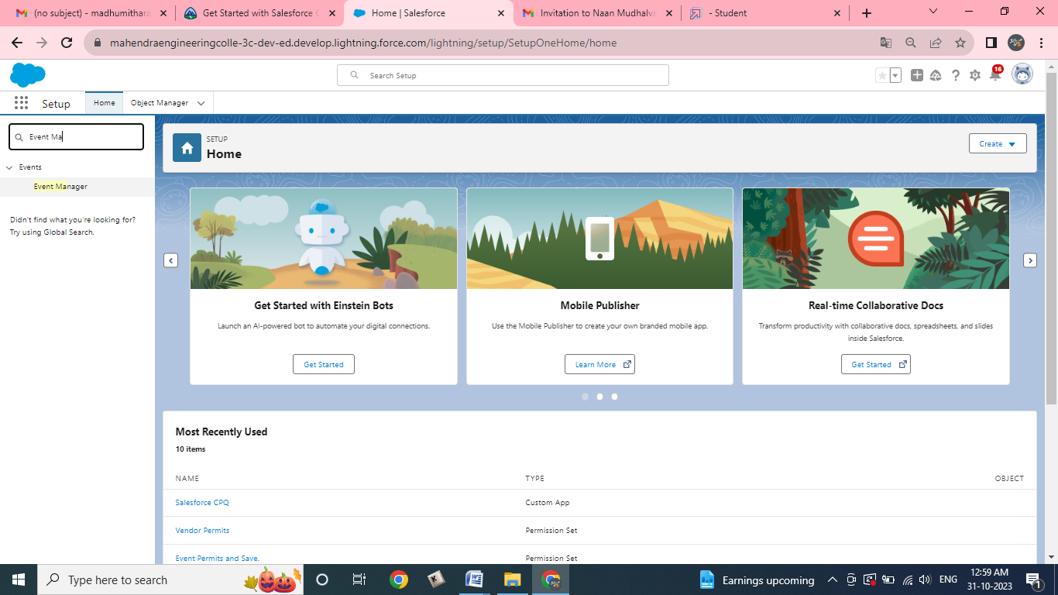

Click on Dashboard Tab.

Click on Occasions with Attendees & see records

